Compliance 101 – Style Guide
XYZ Company

Font | Headings: Verdana, 18pt, Bold  Body: Verdana, 12pt  Blocky Numbers: Franklin Gothic Heavy  Color: R17, G60, B97
Color palette | 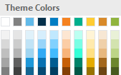
Image Mask | Black rectangle, 15% transparency
Navigation | Use native SL player navigation (arrow and text).
Slide BG Color | White
Storyline Player | Dark
Story Size | Custom: 960 x 720
Button style

